**Zoho Social Web Application**

**Front end:**JSP,JavaScript,CSS

**Back end:**Java,Servlet programming

**Database:**Postgresql

**Description:**A social media-like application where users can connect with others,make friends and share thoughts, photographs, and videos

**ER Diagram:**

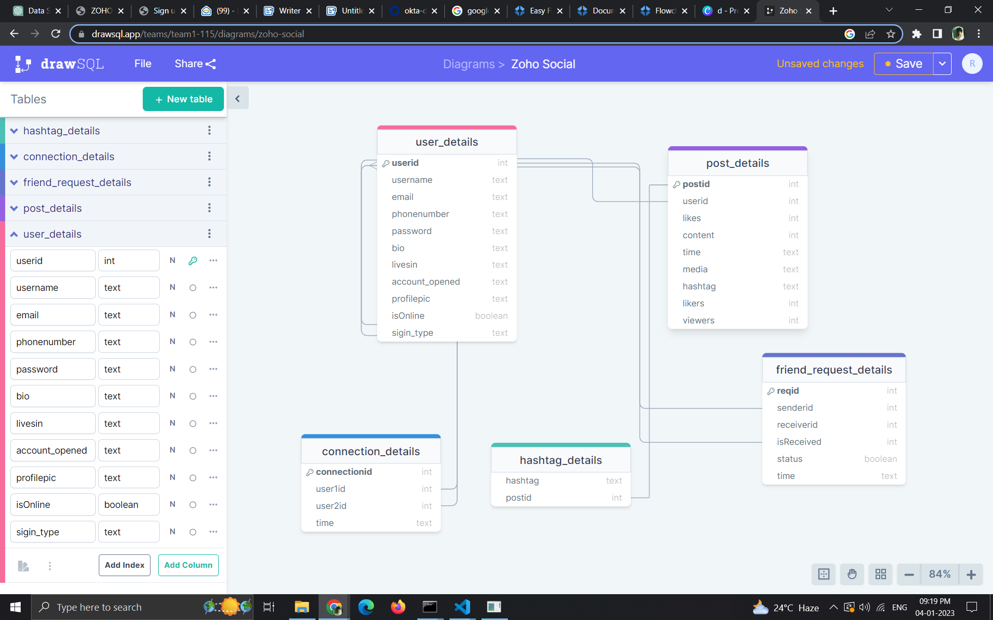

**Index-page:**

Provided with two options of either user can login or register.

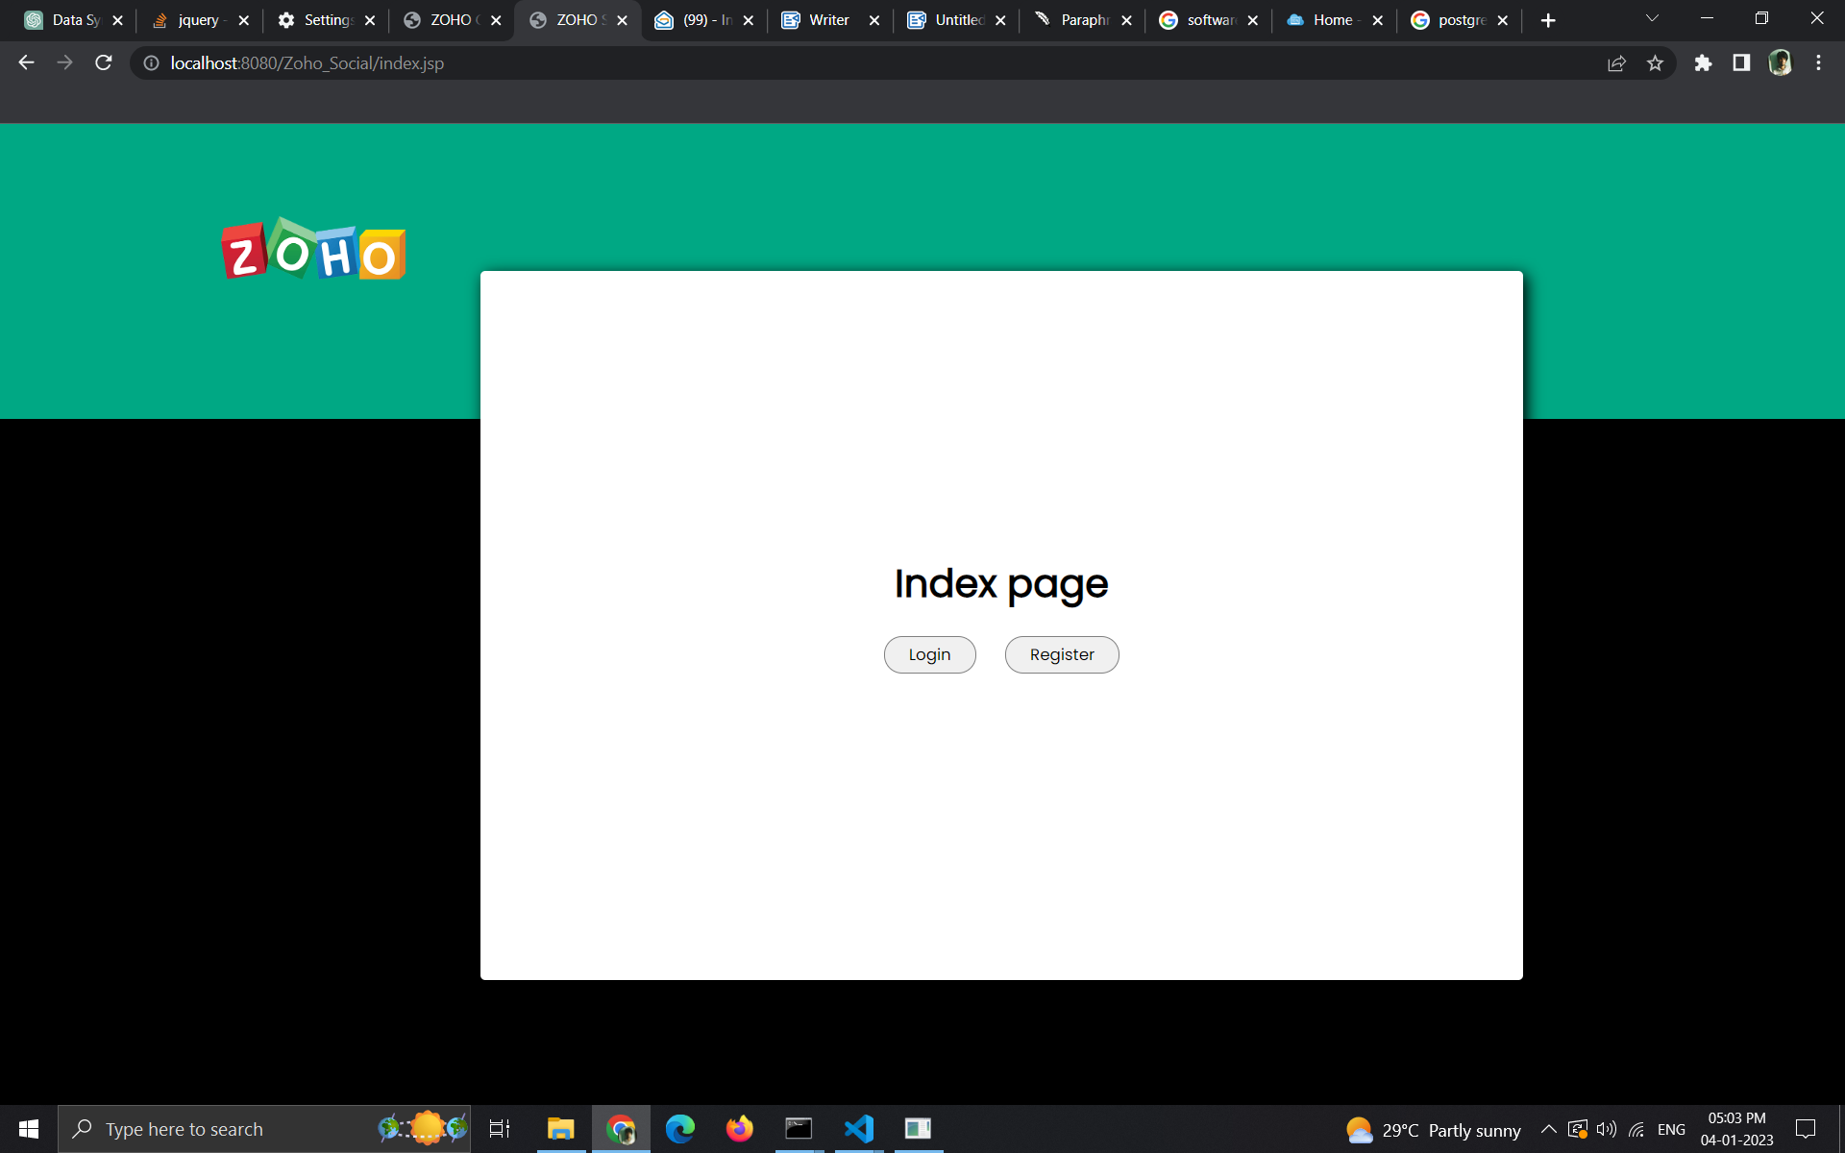

**Login-page:**

Provided with three cases of login:

**Case 1:**one can manually Login into his account using any combination of Email Id or Phone number or Username with password.

**Case 2:**one can Login into his/her account with his/her Google Account.

**Case 3:**one can login into his/her account using an SingleSignOn(**SSO**)

username and password Provided by Zoho Social.

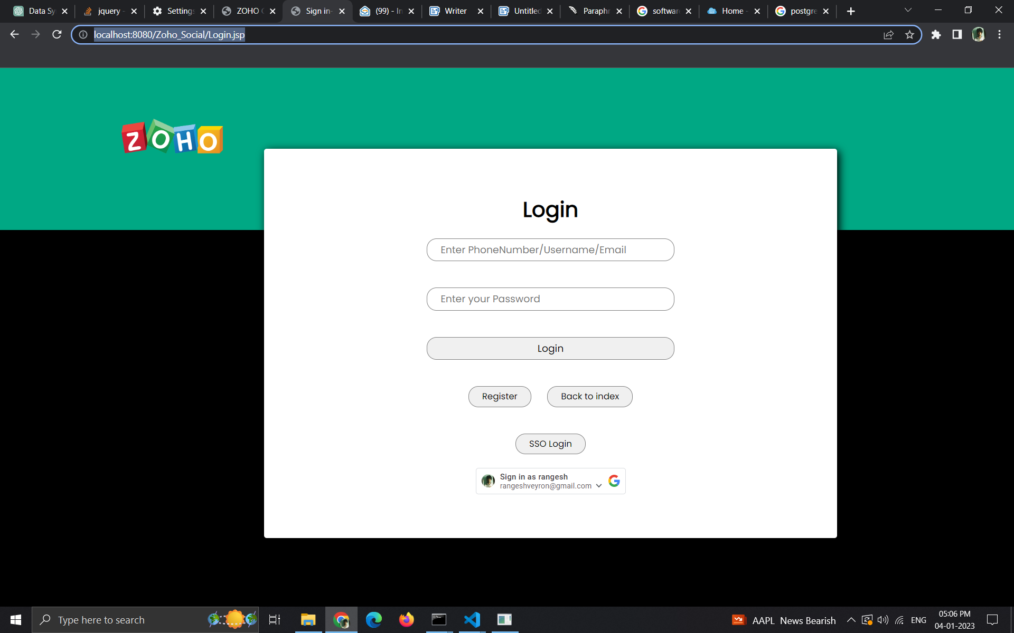

**case 1:**

**\***The user credentials will be authenticated using my data on my database.

**\***In case of entering incorrect password or login credentials alert will be show as below

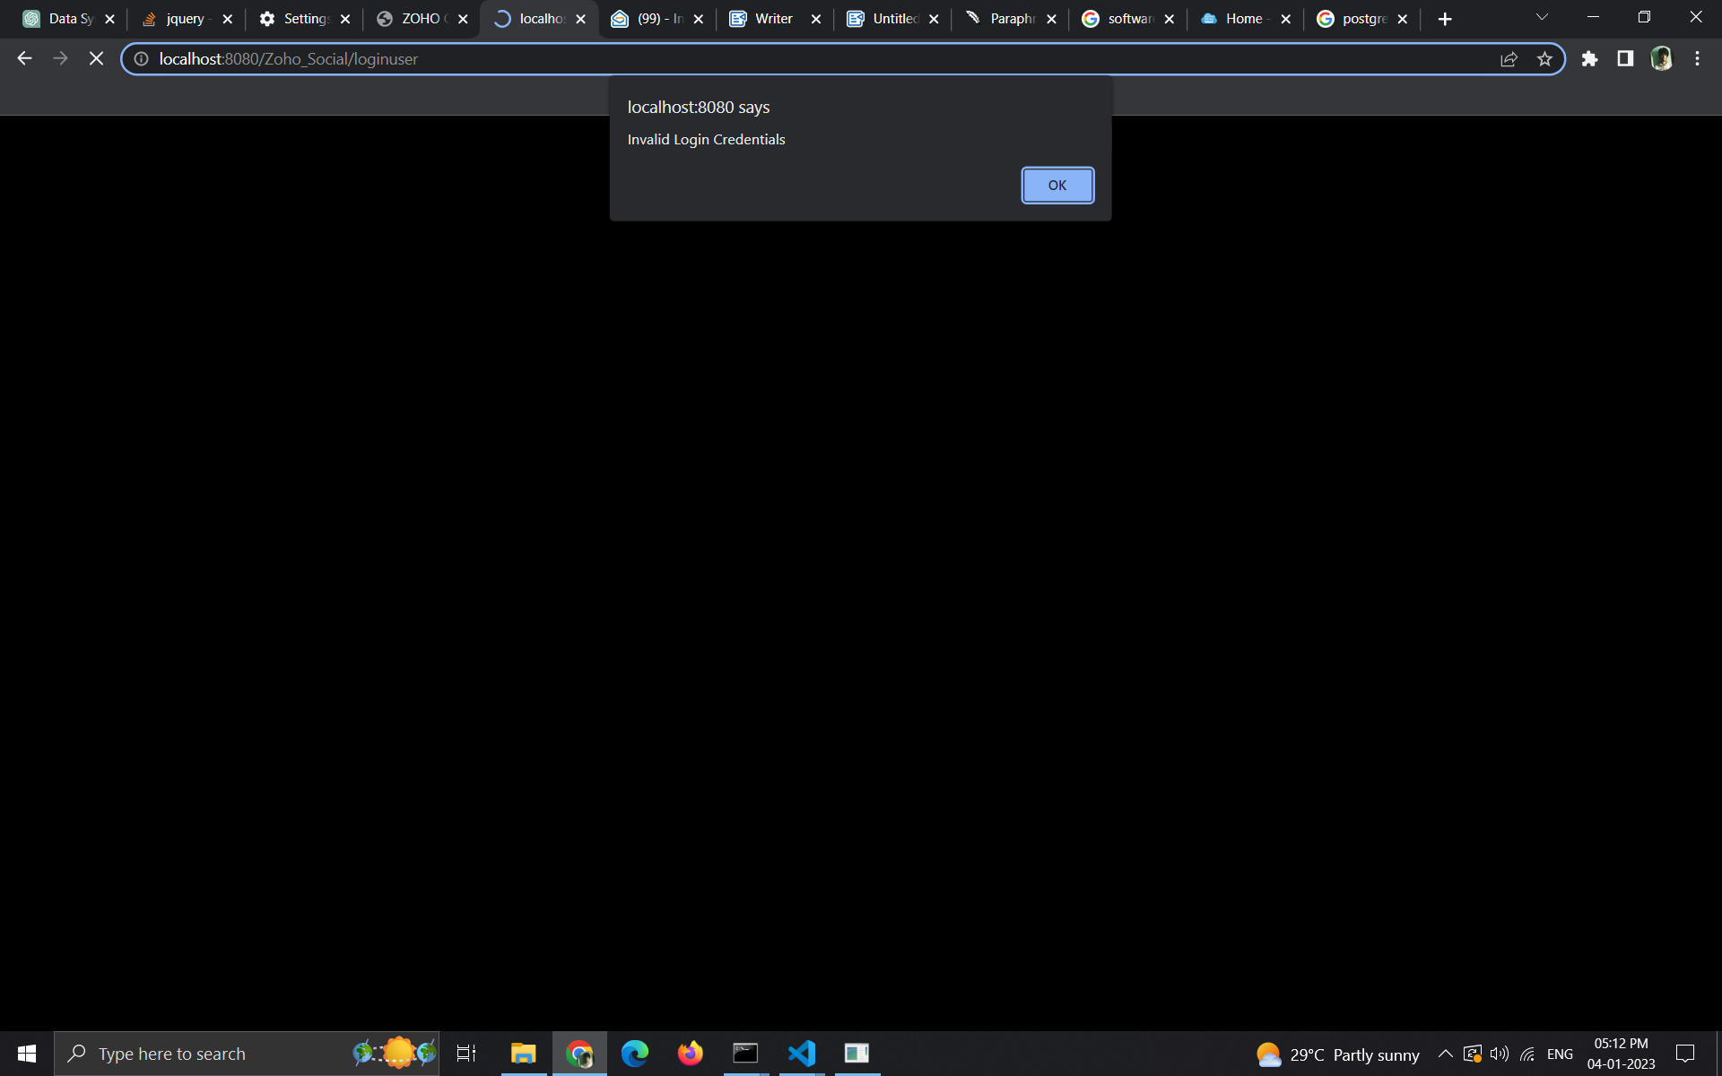

**case 2(Google Sign In):**

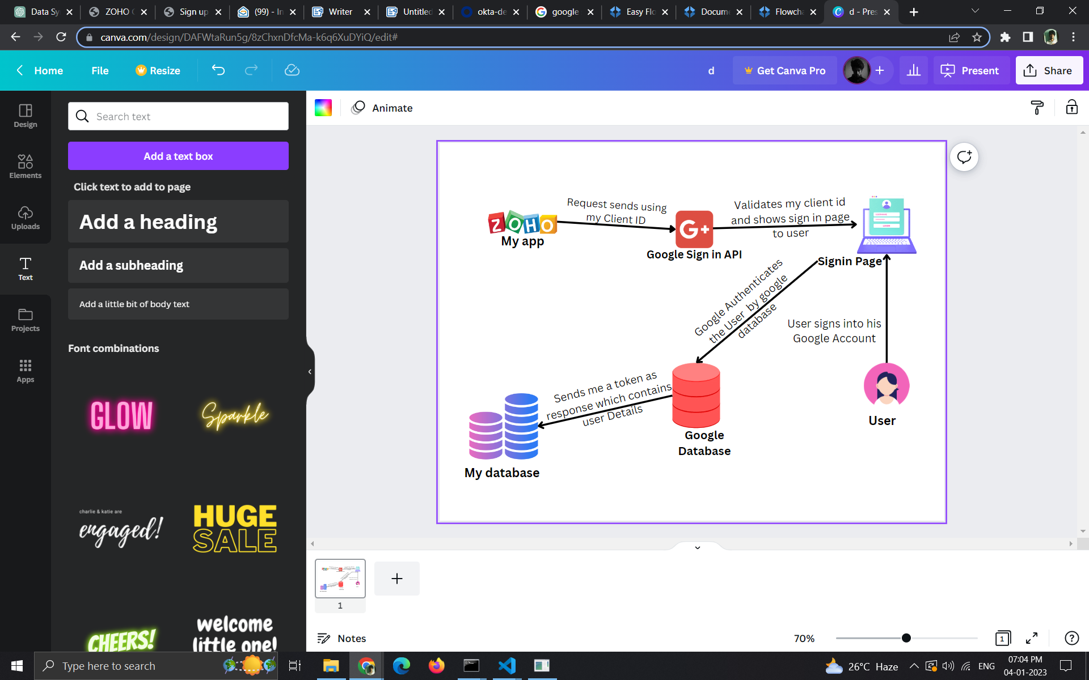

**=>**one can login/register user his/her google account,

here I have used Google Sign-in API

**=>**Request sent to Google using my GoogleClientId

**=>**Get the token from google API containing the User Credentials in its payload(Response) I will take that credentials and check with my database then it will be registered or logged in based on the existence of that data in my database.

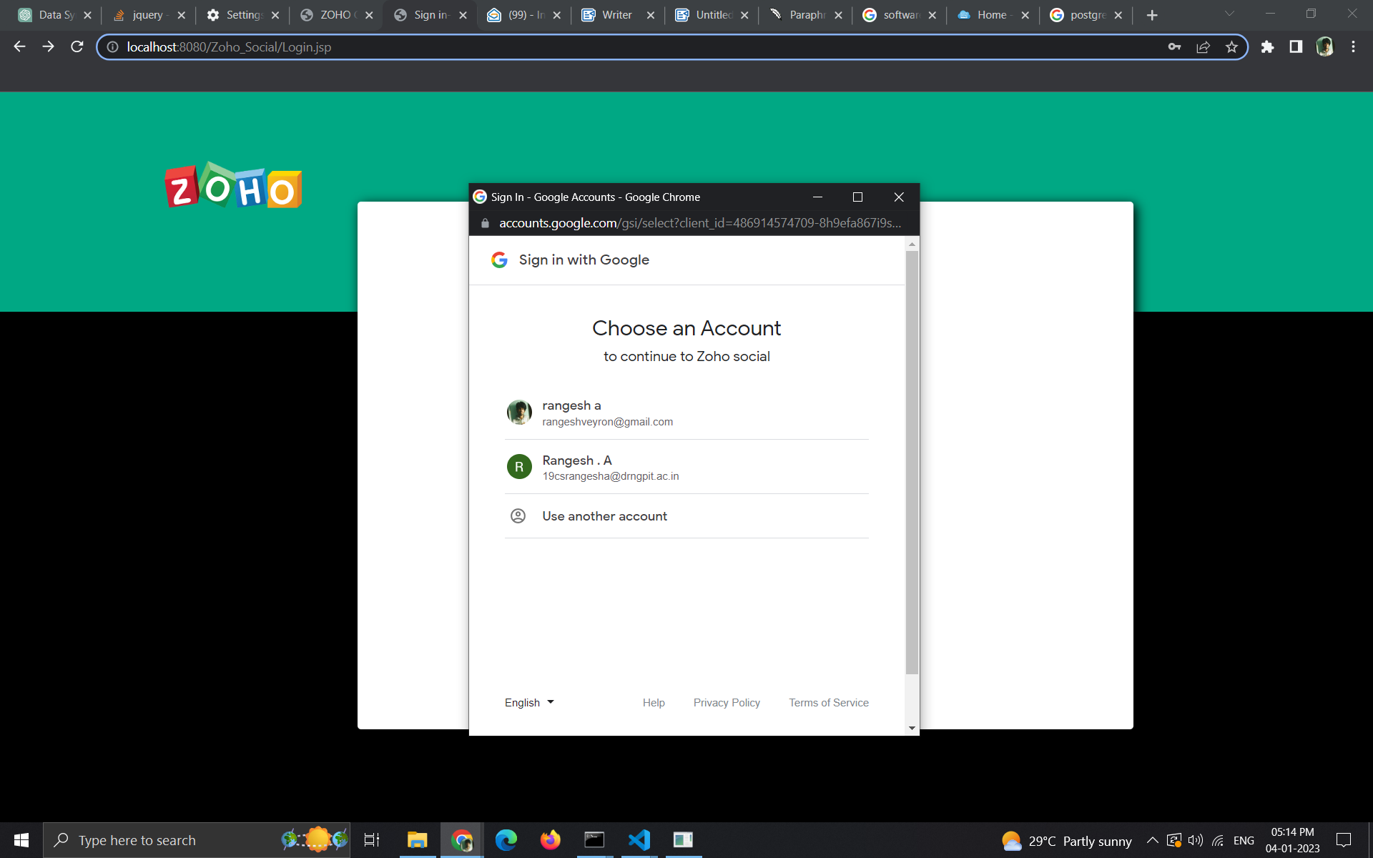

**Case 3 (SSO):**

**=>**Here one can login into his/her account( SingleSignOn(SSO) enabled) using the credentials which is preassigned by me in my Okta's developer Account.

**=>**i will redirect the user towards the SingleSignOn URL Given by Okta(**Identity Provider**) to me

once they click on SSO button in my login page.

**=>**the user has to enter his/her credentials which is static assigned by me(**Service Provider**).

**=>**they can reset their password for their first signup

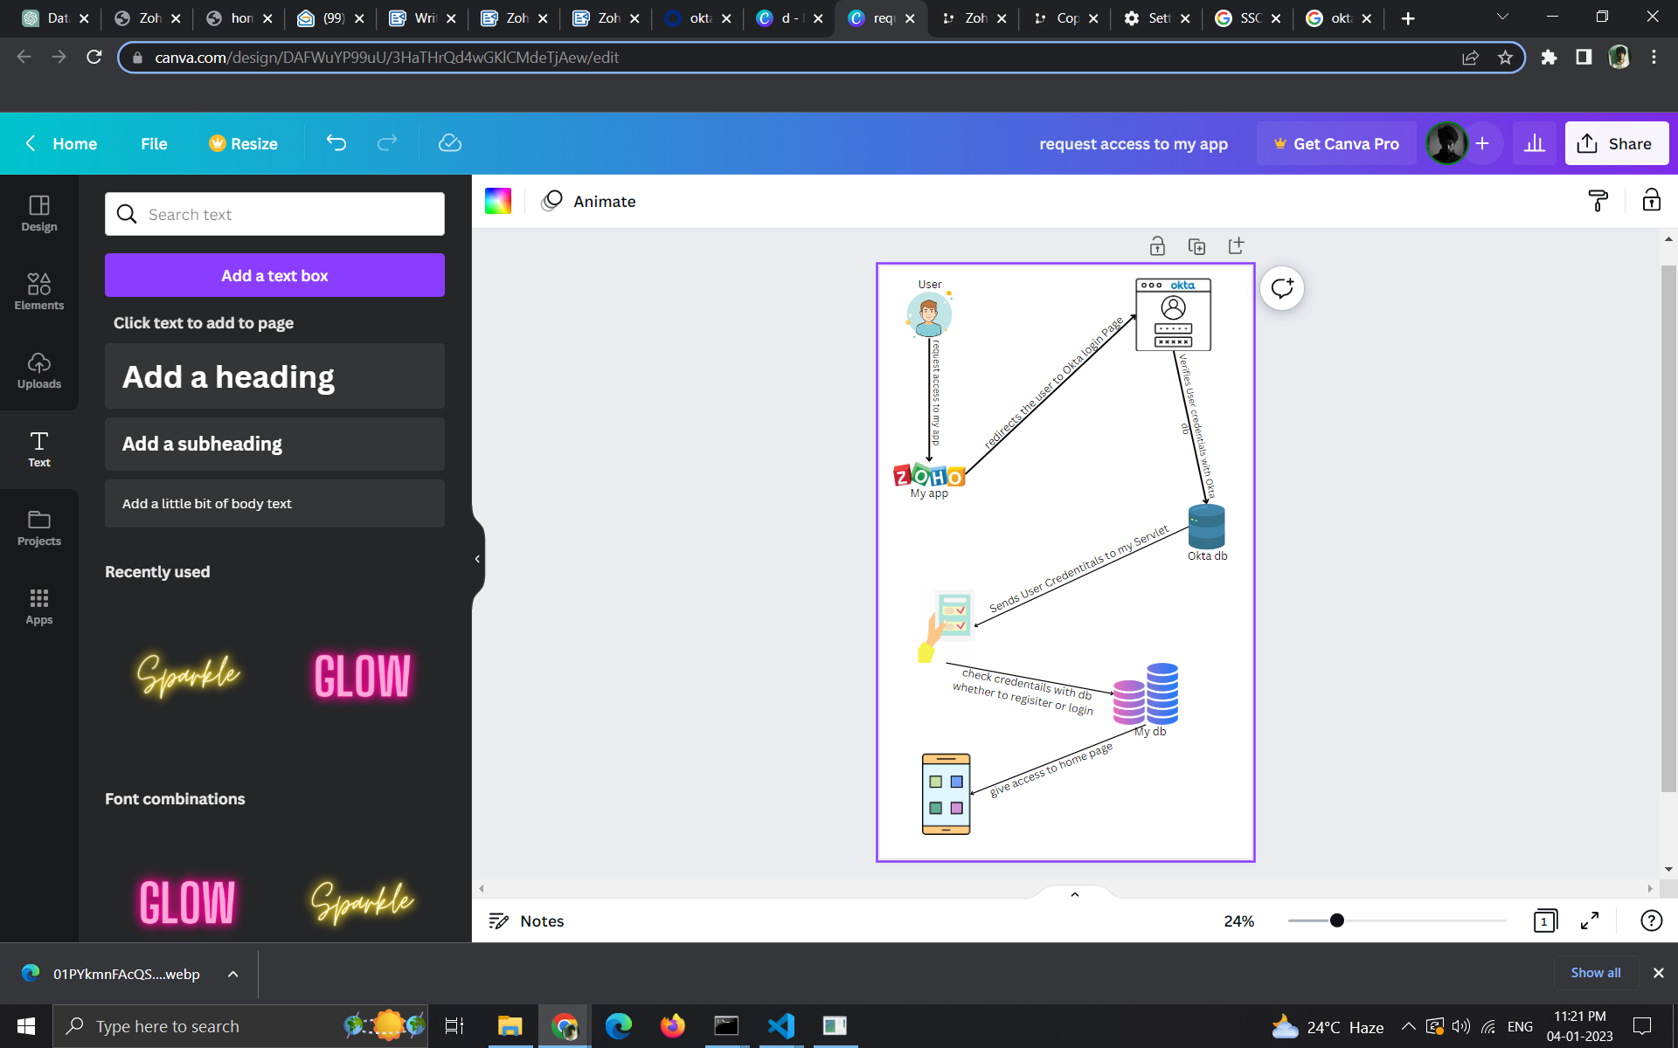

**SAML**

**=>**once the user enters the correct credentials the Okta will send an SAML response to my assertion Consumer Servlet.

**=>SAML Response** contains the Certificate Authority's Signature.

**=>**i will get that SAML Response in my Assertion consumer Endpoint

and start validating the CA's Signature.

**=>** I have already provided with the CA's Certificate which Contains the public key of CA.i will verify the Signature by Applying Cryptographic Algorithm on Signature using the public key in my Local machine.

**=>**Once the Okta's Identity is confirmed the Message is Accepted and I will get the User Credentials from the SAML response

**=>**then using that credential I will register/login into the Zoho Social based on the existence of that credential in my database.

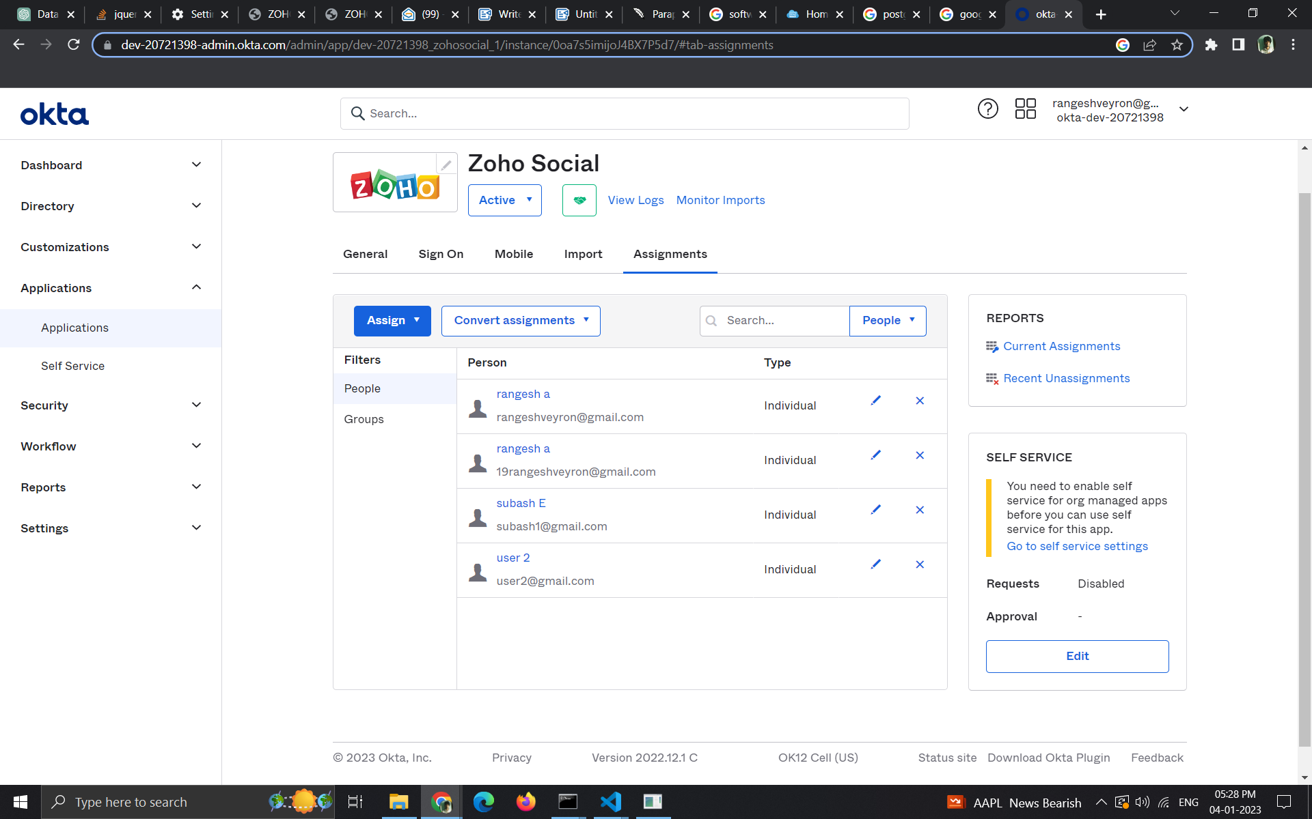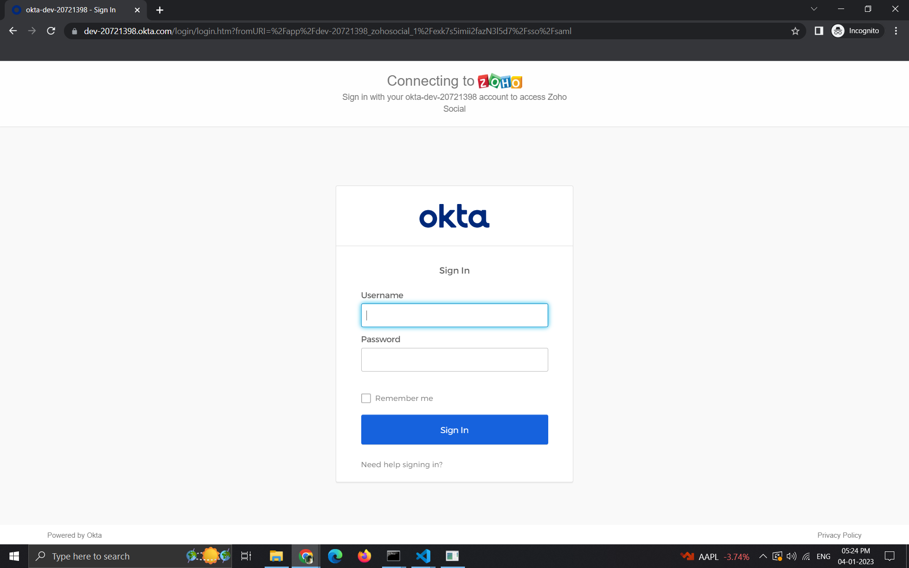

**SAML workflow:**

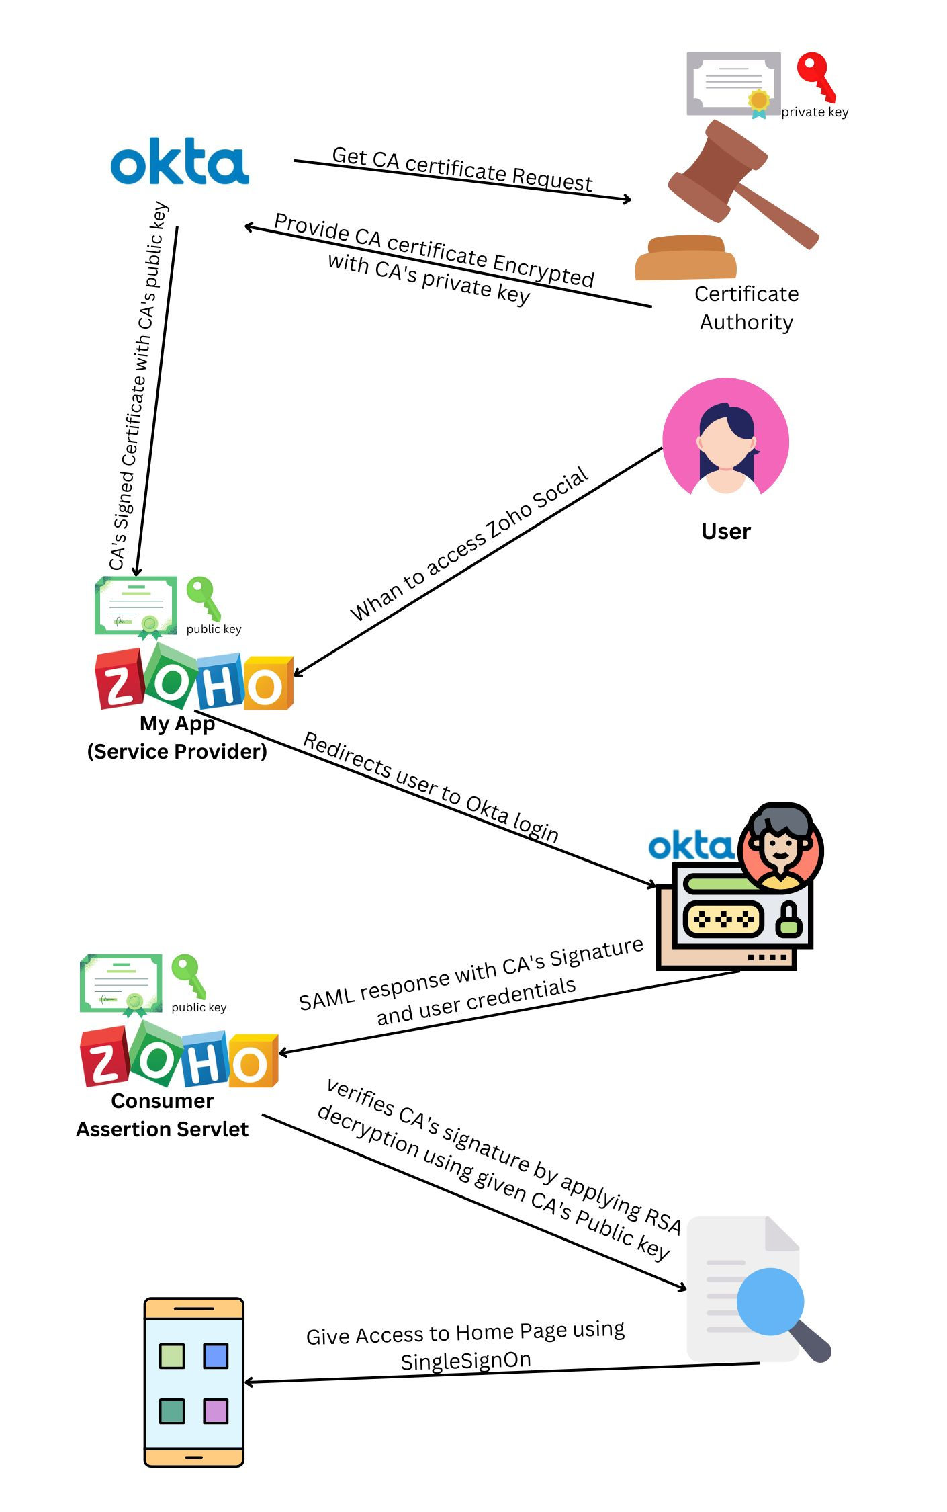

**Register-page**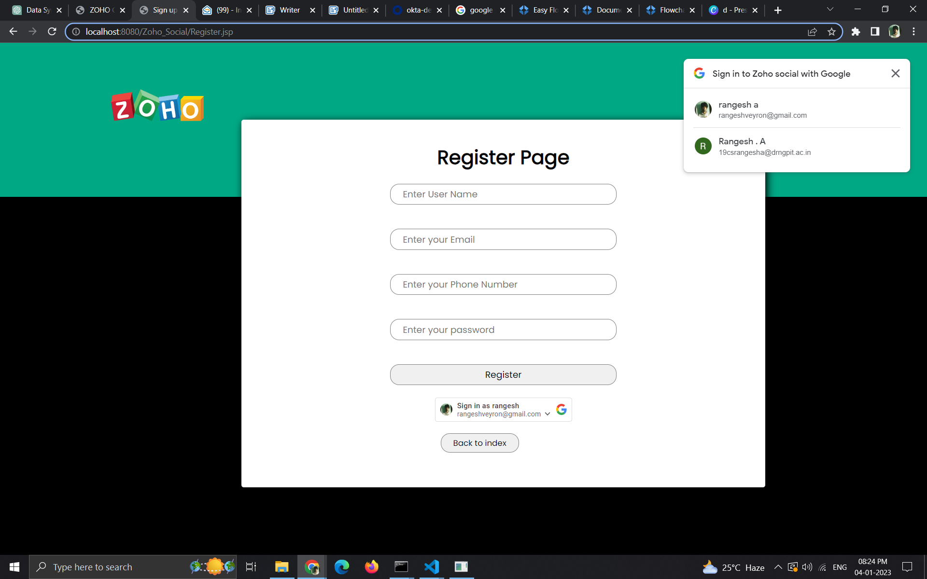

**Case 1:**User can manually Register using their Credentials.

**Case 2:** User can use Google Signin to get Registered into Zoho Social without manual data enter.

**Home page:**

**(1) home page :**

User can view the posts(Image/Video/Text) of their friends in his home page.

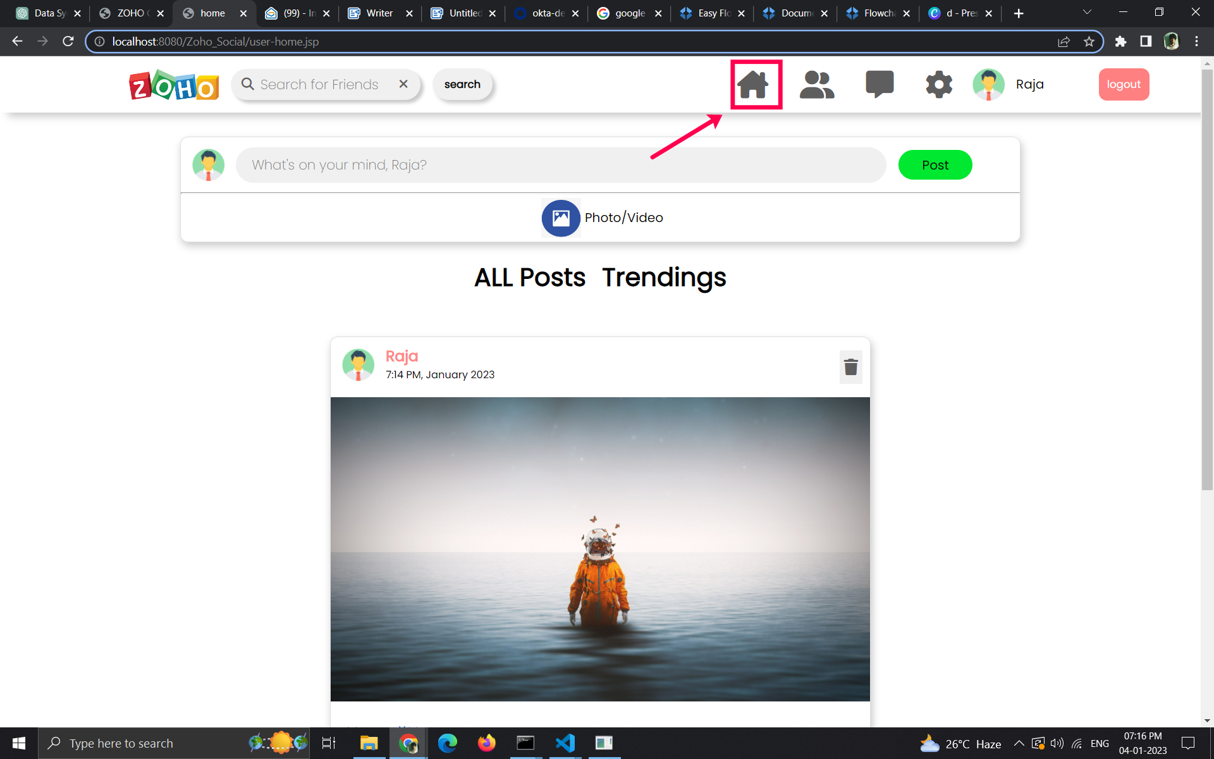

**(2)new Post**

**=>**User can post Image/Video/Text by previewing the media which will be available to their friends in thier home page.Multiple #HashTags can be inserted as the text which will be automatically seperated by some bussiness logic.

**=>**The images and Videos are stored in myContext Filepath.

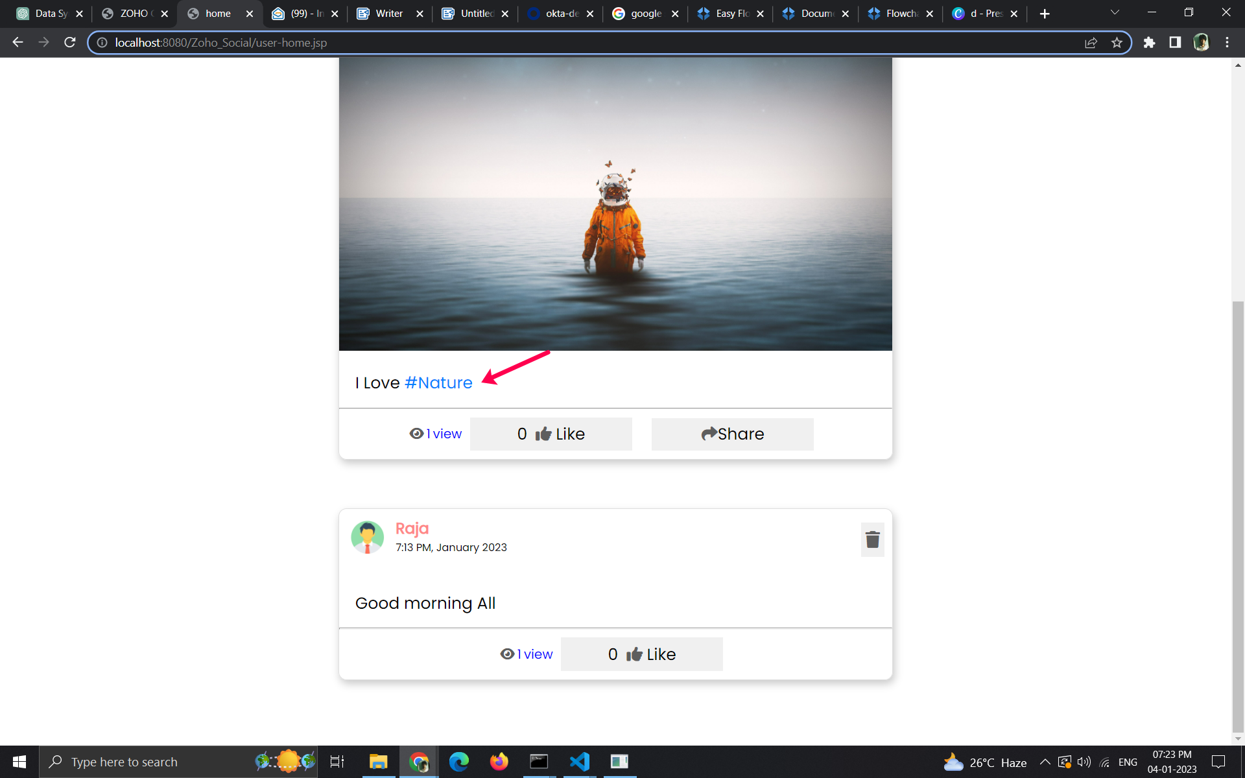

**(3)Like/share/views**

**=>**One can Like the post by clicking the like button and the views will be automatically calculated based on DIV's position on our Window which will be saved in the database.

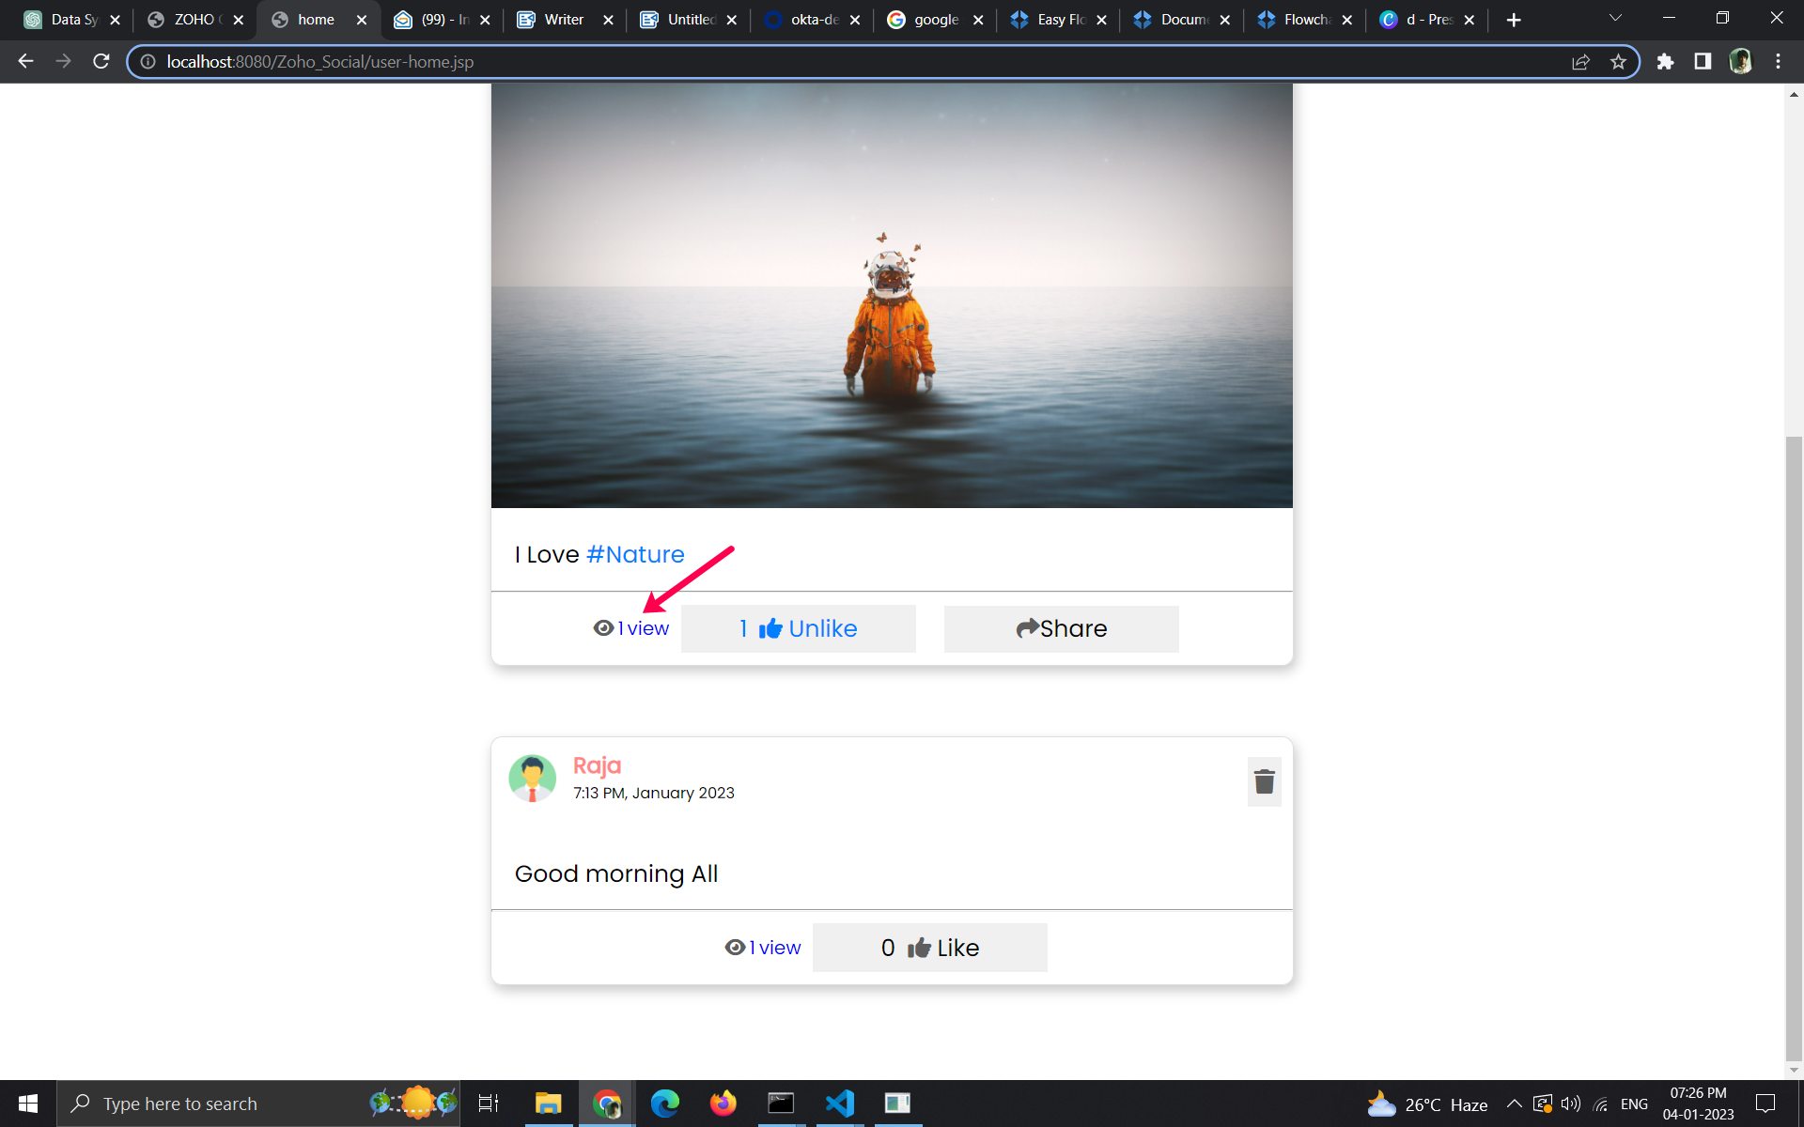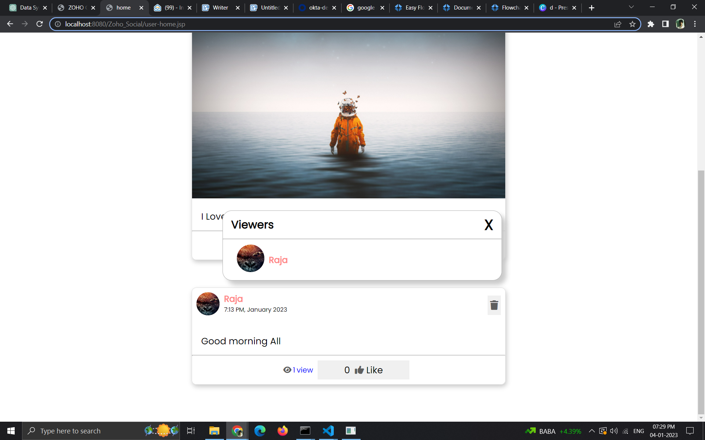

**=>**one can view the viewers of the post by clicking view button.

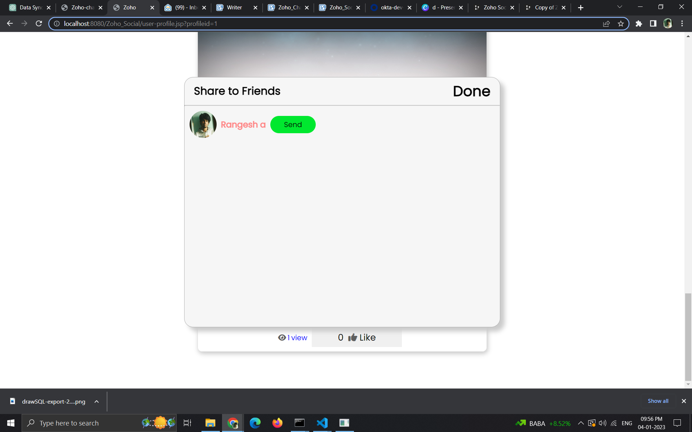

**=>**User can share the post to his/her friends which will be shared on Zoho Chat.

**(4)Delete post;**

**=>**The Current User can delete only his/her post by taping on the trash can symbol.the post details will be deleted in my database and the post file(image/video) will be deleted in my Context path.

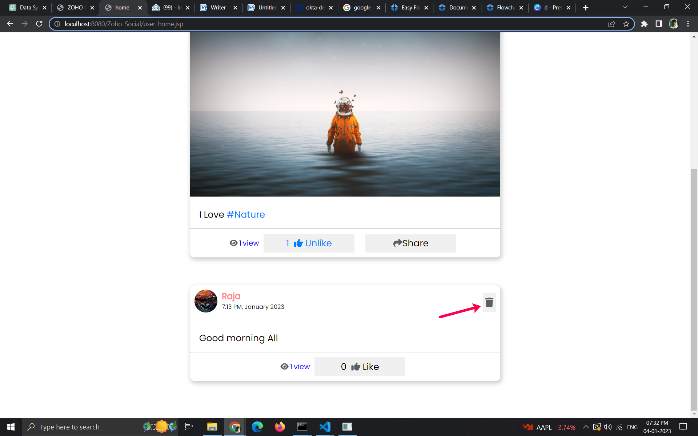

**(5)Trending Hashtags:**

**=>**The #Hashtags of all posts are being recorded in my database which is used to get the trending posts based on the number of posts on the particular #Hashtag.

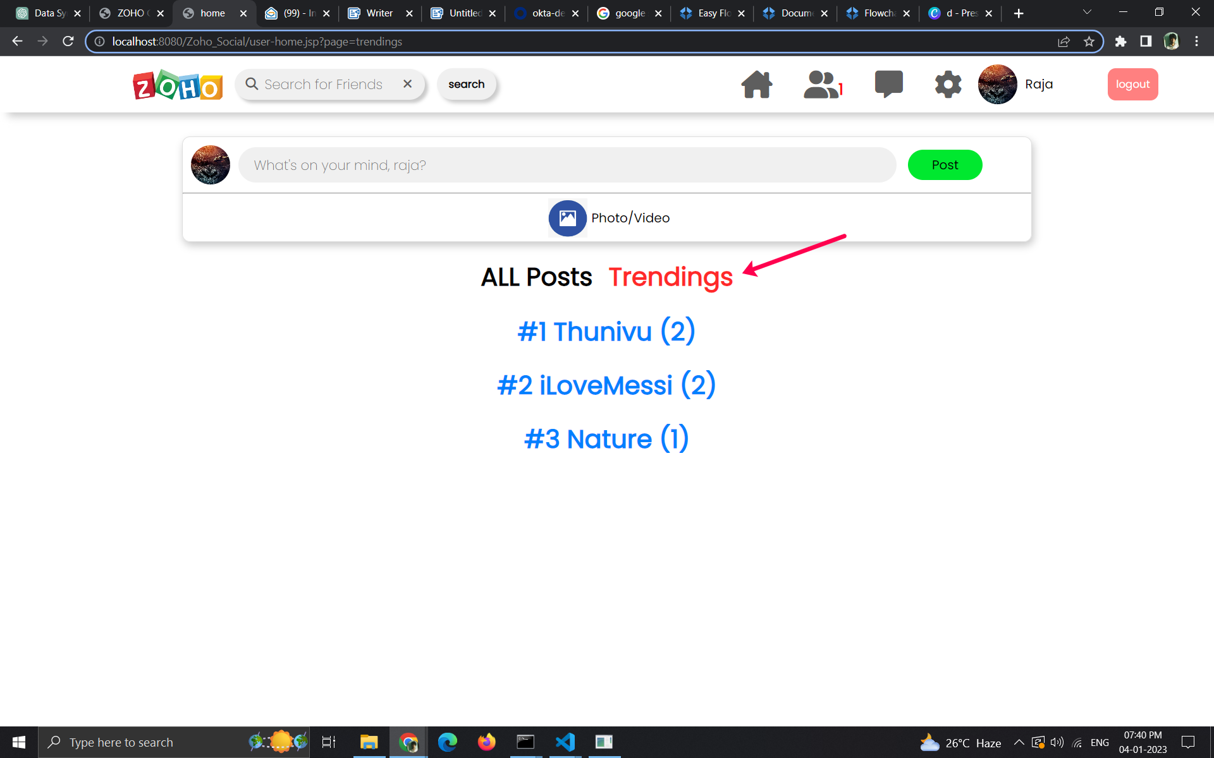

**=>**The posts based on the particular hashtags can be filtered out by clicking on the hashtag.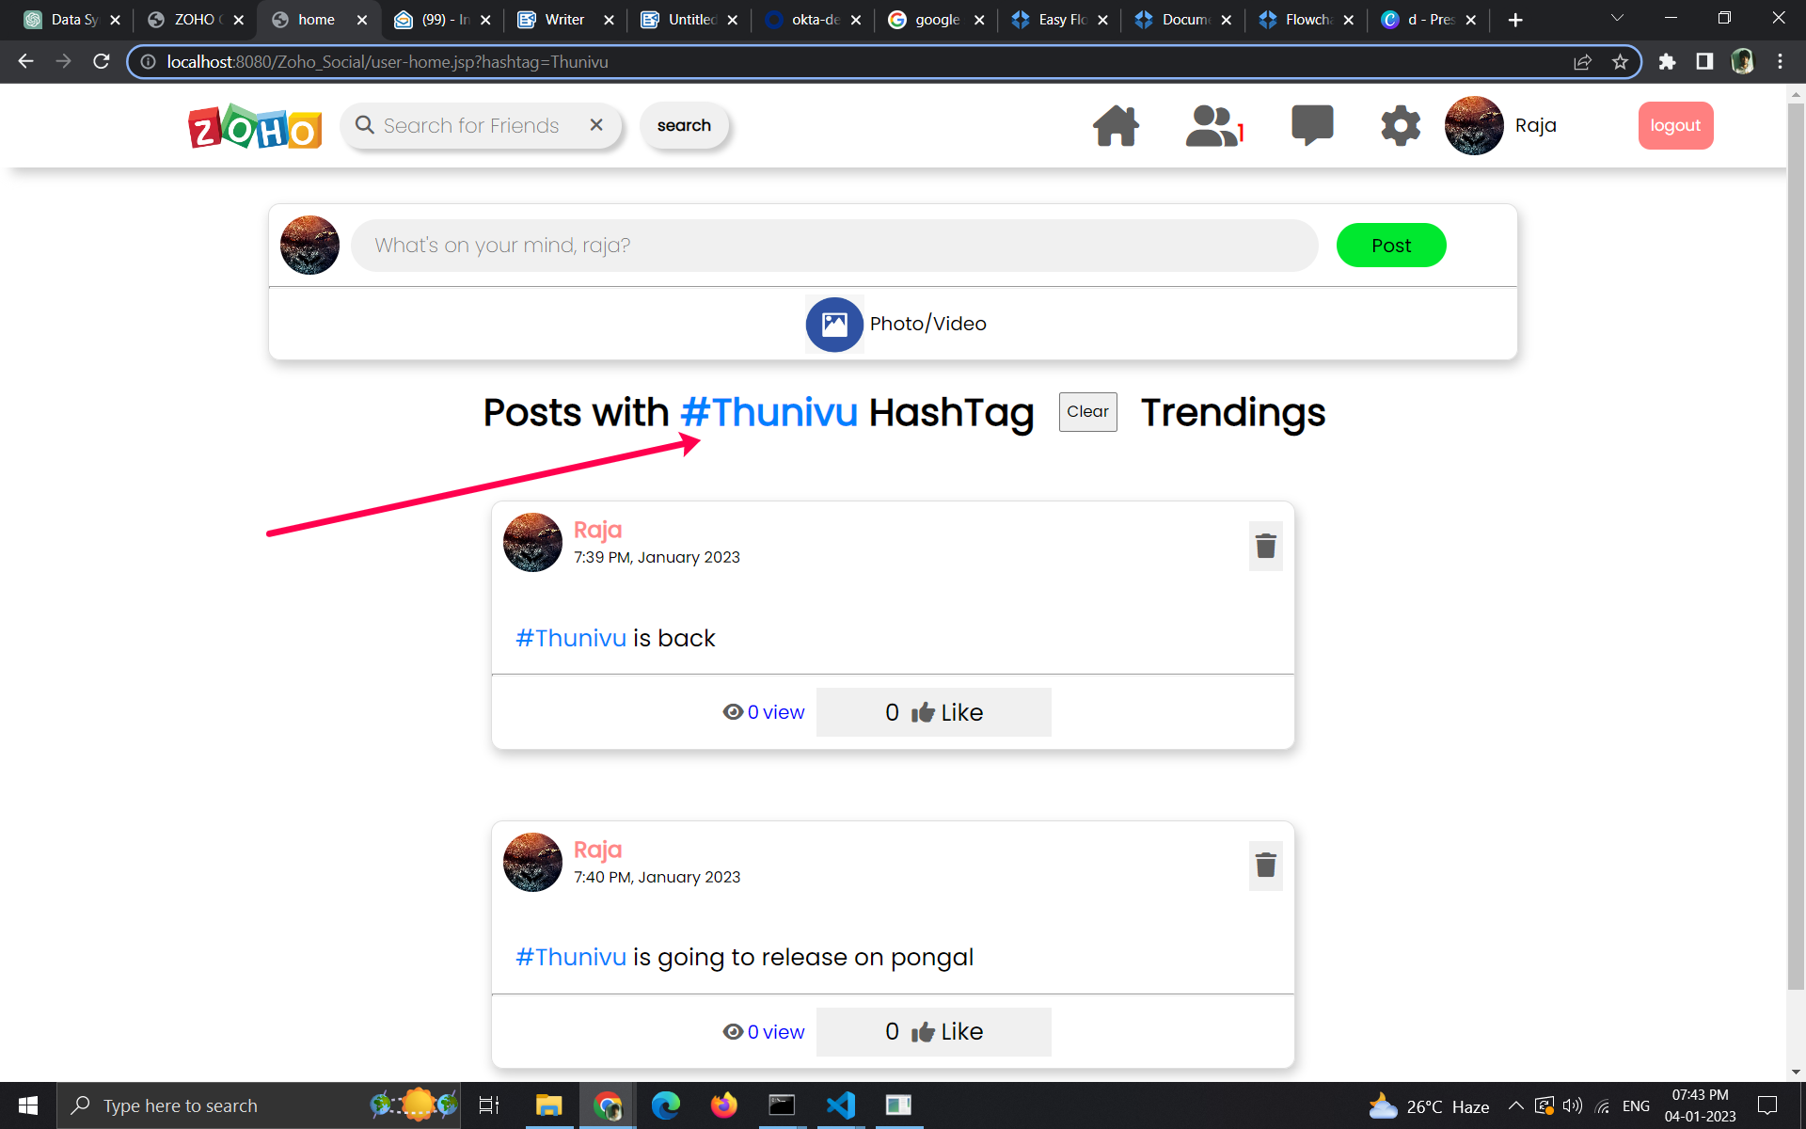

**Connection Page:**

**=>**The friend requests are seen on the freind request tab 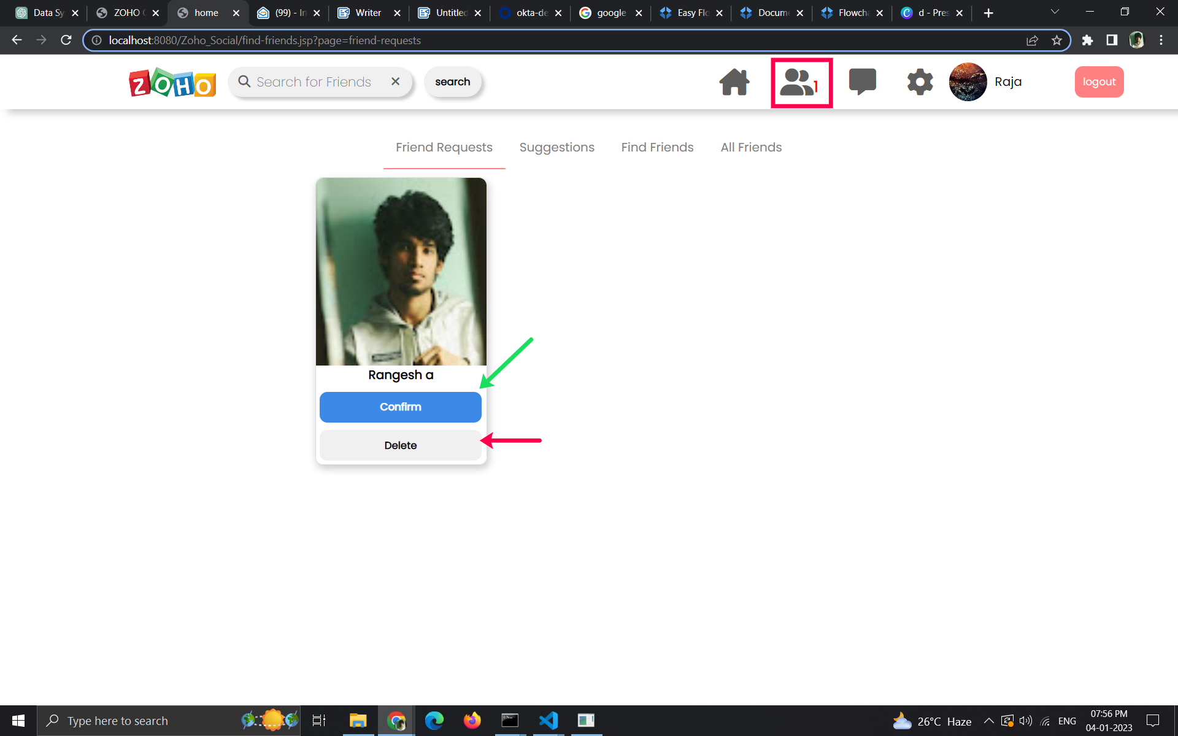

**=>**The find friend tab is used to search for new friends and specific users can be searched using search tab on top.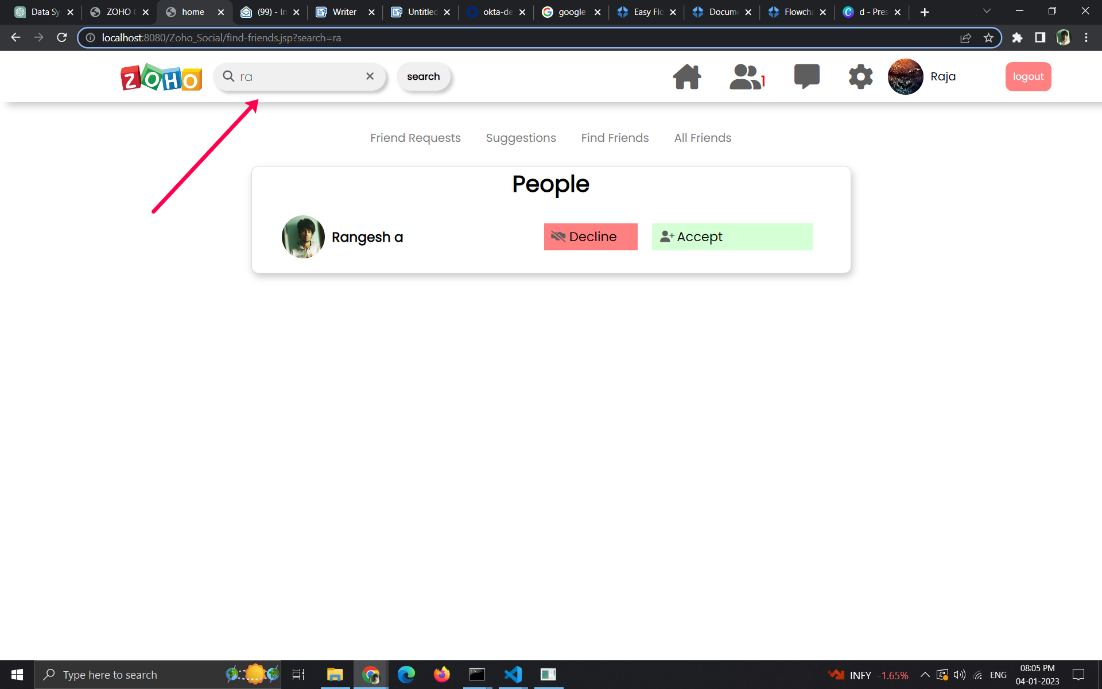

**=>**All friend tab shows all the friends of the user.can unfriend using the unfriend button.

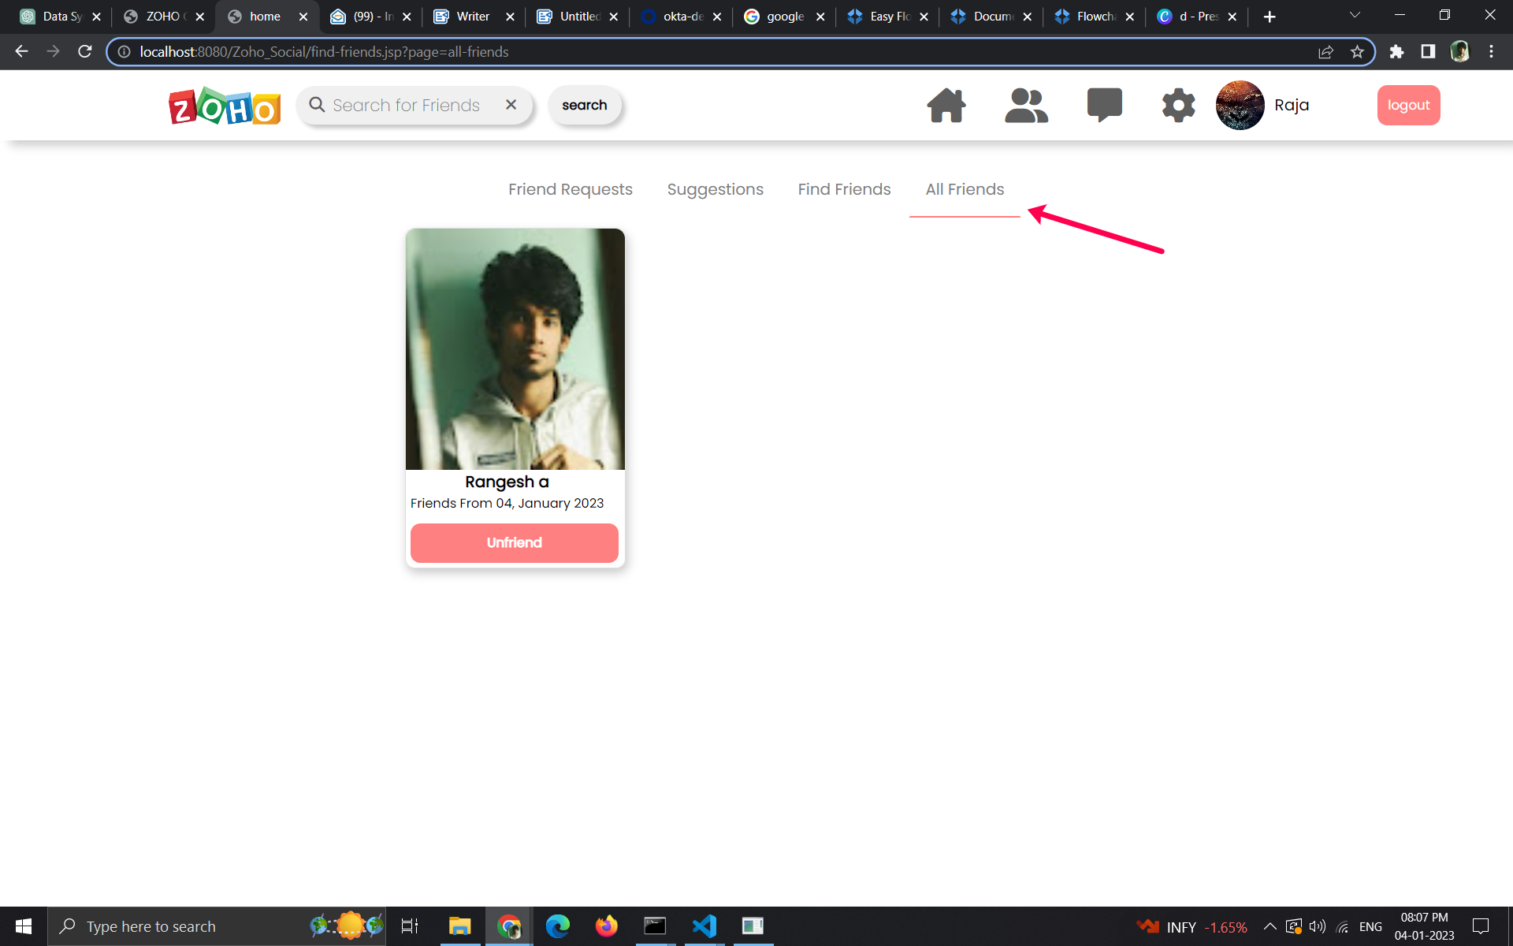

**Settings Page:**

**=>**User can edit his/her details except phone number,email.

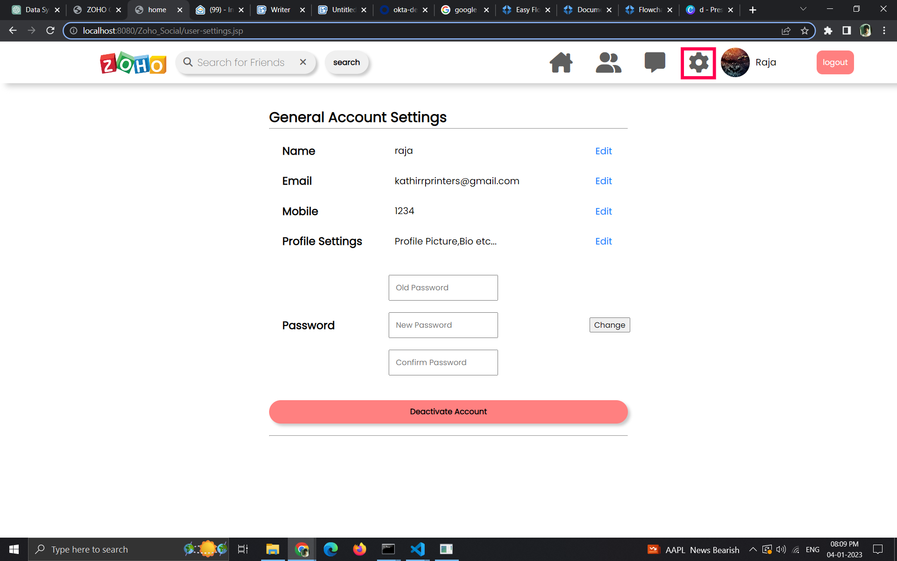

**Edit Page:**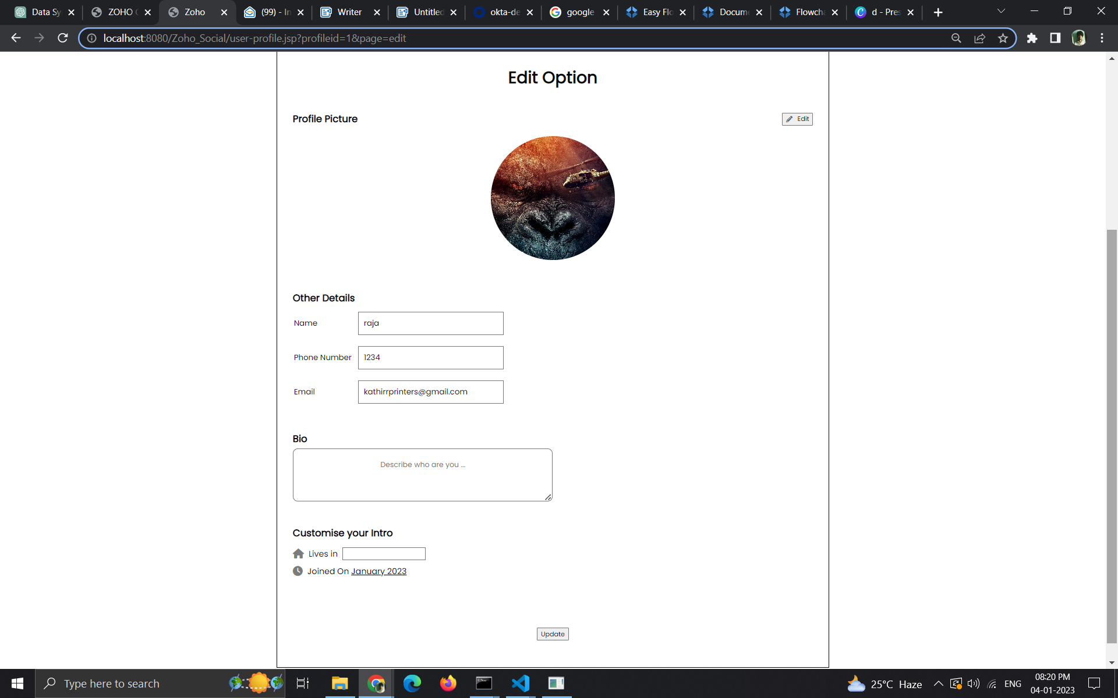

**Profile Page:**

**=>**User can view all the his details Posts,Friends and user informations.

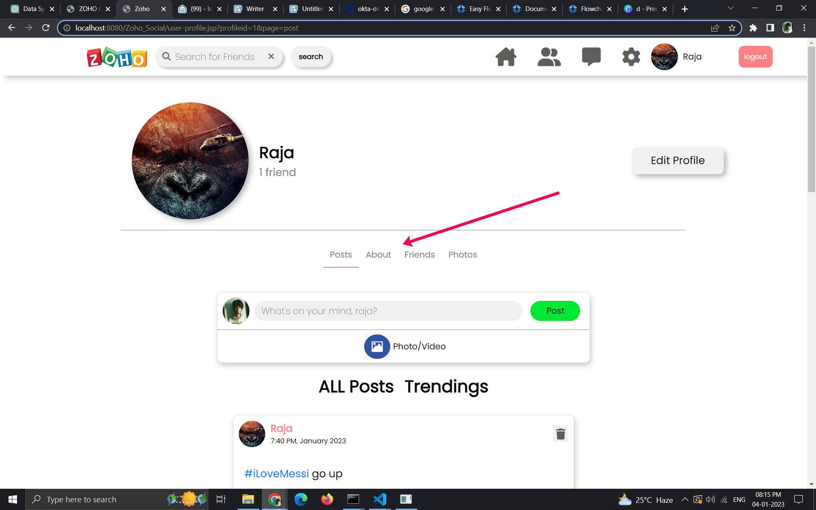

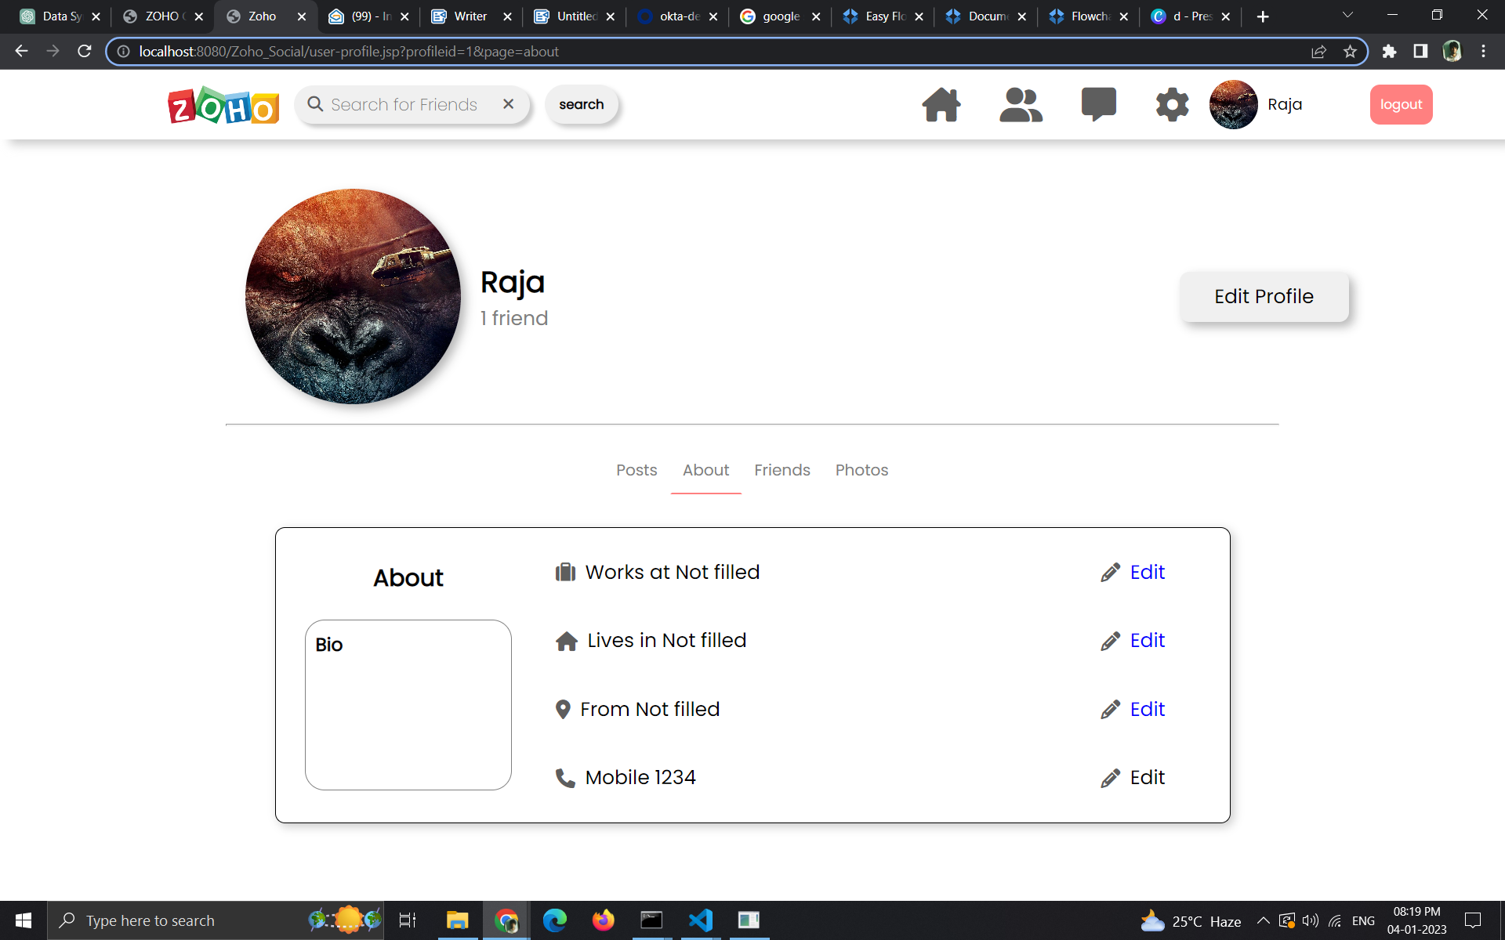

logout User which invalidates the current Session on browser.

